# Chapter 3: Hydraulic Analysis of Walnut Cove Wetland Cells

## Abstract

In late April 2019, known rejuvenation techniques, accumulated detritus removal and vegetation reestablishment, were conducted in wetland cell 1; meanwhile, wetland cell 2 was left in its original aged condition to function as a reference cell. To evaluate the internal hydraulics of the two cells and to evaluate the impact of wetland rejuvenation techniques on hydraulic performance several Rhodamine WT tracer tests were conducted. Five tracer tests were conducted in wetland cell 1 and four tracer tests were conducted in wetland cell 2, for nine total tests. Residence time distributions were built from the tracer test results using the method of moments and by fitting a gamma probability distribution function. The hydraulic performance of the wetlands were compared using a hydraulic efficiency index (λe), a short-circuiting index (τ10/tnom), and a mixing index (σΦ2) as recommended in Liu et al (2020). Average pre-rejuvenation λe, τ10/tnom, and σΦ2 values of 0.13, 0.09, and 0.35, respectively, were all indicative of compromised or poor performance, while average post-rejuvenation values of 0.58, 0.44, and 0.07, respectively, were indicative of average to excellent performance. Hydraulic performance values for cell 2 remained relatively similar over the course of the study with average λe, τ10/tnom, and σΦ2 values of 0.19, 0.05, and 0.23 during the period before detritus removal and values of 0.22, 0.16, 0.27, respectively, during the period after detritus removal. All the cell 2 values were indicative of compromised or poor performance. Conversion of hydraulic performance index values from poor to acceptable and excellent in cell 1 relative to the consistent poor performance in cell 1 provides strong evidence that the rejuvenation techniques of detritus removal and vegetation reestablishment improved the hydraulic performance of an aging constructed wetlands.

## 3.1 Introduction

Constructed wetlands remove nutrients from the water column via a combination of abiotic and biotic processes facilitated by interactions between the various constituents of the wetland. Interactions dependent on microorganism activity or plant uptake, i.e. nitrification/denitrification and assimilation, are heavily dependent on the amount of time the water resides in the wetland (Kadlec & Wallace, 2009; Toet et al., 2005). Examples of the relationship between nitrogen removal and time can be seen in the microcosm studies conducted by Gersberg et al. (1983) and Ingersoll and Baker (1998) with both studies observing that decreasing hydraulic loading rates (i.e. increasing duration within the wetland system) resulted in increasing nitrogen removal efficiency.

The duration of time that water spends between the inlet and the outlet of the wetland is known as the wetland residence time, or simply residence time. Residence time is function of wetland flow dynamics. The most common approach to wetland flow dynamics are to assume that the wetland system acts as an ideal, plug-flow reactor (Carleton, 2002; Kadlec, 2000; Kadlec & Wallace, 2009). Wetland performance can then be predicted using plug-flow chemical reactor models built using principles borrowed from chemical engineering. Assuming wetlands act as ideal plug-flow reactors, all the influent water at time, t0, will uniformly pass through the wetland and exit the wetland at a future time, *tn*, determined by equation 1 as the time required for a complete volume exchange in the wetland (Kadlec & Wallace, 2009; Persson et al., 1999; Wahl et al., 2010).

$t_{n}=\frac{V}{Q}$

Equation 1

Where, *tn* is the nominal wetland residence time (days), V is the wetland volume (L/d), and Q is the flow rate (L3/d).Wetland treatment performance modeled using plug-flow hydraulics represents the best-case scenario for pollutant removal because it assumes the entire wetland basin is utilized for treatment.

However, since the early 1990s, hydraulic performance tests conducted using inert tracers (i.e. tracer tests) have shown that assumption of uniform plug-flow is not appropriate for modeling constructed wetland hydraulics (Kadlec & Wallace, 2009). Short-circuiting, obstructions, and dead zones in the wetland produce nonideal flow patterns. Over time, the high rate of organic matter production and anaerobic conditions in constructed wetlands leads to a substantial accumulation of detritus. Accumulated detritus causes preferential flow paths and obstructions to form within the wetland resulting in an eventual decline of hydraulic performance and ultimately a decline treatment efficiency and the removal of the wetland from the treatment train.

The nonideal flow patterns reduce the efficiency of wetland and cause treatment predictions based on plug-flow conditions to overestimate the treatment ability of the wetland. In terms of constructed wetland implementation, the lack of uniform flow increases the land area required to achieve the same level of treatment that was predicted using the plug-flow reactor model. The departure from ideal, plug flow conditions results in an actual residence time, τ, that is less than the theoretical tn. The ratio of τ/tn is referred to as the hydraulic efficiency, e, of the wetland and it represents the departure of actual flow from ideal plug flow (Thackston et al., 1987). Since tn assumes plug flow with the entire volume of the basin is used; therefore, *e* is also a measure of the volumetric efficiency of the basin.

The actual flow through a wetland can be described by a distribution function of residence time represented by a Residence Time Distribution (RTD). An RTD is developed for hydraulic tracer tests by measuring the outflow and outlet concentrations of pulse-injected inert tracers. The developed RTD represents the degree of residence time variability within the system (Persson et al., 1999). The RTD of a wetland system is a positively skewed distribution function with an extended tail. The flow represented by a wetland RTD function is somewhere between the distribution of a plug flow system and a single continuously stirred tank reactor (CSTR). As a result, the hydraulics of a wetland systems can be modeled as a number (N) of tanks-in-series (TIS), with a 1-TIS representing flow through a single CSTR and ∞-TIS representing theoretical plug-flow (Kadlec & Wallace, 2009; Persson et al., 1999).

Wetland hydraulics can be characterized by quantifying the mean (τ) and variance (σ2) of the RTD (Bodin et al., 2013). The mean (τ) represents the actual mean residence time of the tracer within the system, while the variance (σ2) represents the spread of the tracer (i.e. mixing) within the system. With the mean and variance of the RTD, the number (N) of TIS can be estimated using equation 2.

$N=\frac{τ^{2}}{σ^{2}}$ (Equation 2)

There are two common methods for deriving the mean and variance of the RTD from the measured tracer experiment data: 1. the method of moments using numerical integration, 2. Modeling the RTD by fitting a gamma distribution to the data (Kadlec & Wallace, 2009). According to Kadlec and Wallace (2009), the method of moments analysis is preferred because it pulls the hydraulic parameters directly from the measured data; however, small concentrations variances in the tail of the RTD can result in false parameter values and shifts in the overall RTD. Advantages and disadvantages of both methods do not allow for the selection of a best method; therefore, the analysis of the measured data was performed using both methods then averaged (Bodin et al., 2012).

Using the method of moments, the RTD can be described by the zeroth, first, and second moments (Kadlec & Wallace, 2009). The zeroth moment represents the fractional character of the RTD function, the sum of which should be unity (i.e. the sum of the zeroth moment should be equal to 1). The first moment is the centroid of RTD and represents the actual mean residence time, τ, for the tracer experiment. The second moment represents the variance of the RTD, σ2, which can be converted to a dimensionless variance of the tracer, σθ2, by dividing σ2 by the square of actual mean residence time (τ2). Using the conceptual TIS model, the inverse of dimensionless variance, σθ2, is the number of TIS, N.

Using the gamma distribution fitting, the gamma distribution is a function of time (t), N, and τ. N and τ are derived from the model during the optimization process that fits the model by minimizing of the sum of squared errors between the gamma distribution and the measured data. From the derived N and τ parameters, the variance of the RTD, σ2, can be calculated using equation 2.

Variable site conditions during tracer experiments make each RTD unique. Therefore, to compare the hydraulic performance of one wetland to another, hydraulic indexes, derived from the RTD and corresponding hydraulic parameters, have been developed as a way to evaluate and compare hydraulic performance (Bodin et al., 2013; Liu et al., 2020; Persson et al., 1999; Wahl et al., 2010).

### Hydraulic performance

There have been several acceptable hydraulic indexes proposed to evaluate the hydraulic performance of a constructed wetland (Bodin et al., 2013; Persson et al., 1999; Wahl et al., 2010). A comparison of eight hydraulic indexes, categorized into hydraulic efficiency indexes, short-circuiting indexes, and mixing indexes, was conducted by Liu et al (2020) using classic test theory consisting of compatibility, discrimination, and difficulty comparisons. Hydraulic efficiency indexes compare the observed hydraulics to the plug flow hydraulics of an ideal system with the same volume and flow rate. A hydraulic efficiency index is the most comprehensive hydraulic index and subsequently the most important hydraulic index for describing hydraulic performance (Persson et al., 1999). Short-circuiting indexes focus on the time at which the tracer concentrations above the background concentration are measured at the outlet (i.e. what is the residence time for the shortest path through the wetland). Mixing indexes quantify the spread of the RTD to quantify the amount of mixing in the basin. The wider the spread of the RTD, the greater the mixing, and the more the wetland acts as a single CSTR instead of a plug-flow reactor (i.e. the greater the mixing, the further from ideal wetland flow). Liu et al (2020) identified major discrepancies between hydraulic efficiency indexes, but only minor discrepancies between short-circuiting indexes and mixing indexes. Liu et al (2020) recommended λe, τ10/tnom, and the Morril Index to quantify hydraulic efficiency, short-circuiting, and mixing, respectively.λe and τ10/tnom were used, as recommended, for this study. The Morril Index was not used as the mixing index, instead the dimensionless RTD variance, σθ2, was used to evaluate mixing. This was deemed acceptable because there were only minor differences in performance between these two mixing indexes (Liu et al., 2020).

### Study Objectives

1. Evaluate tracer tests using both analytical methods currently in practice

2. Quantify the hydraulic performance of an aging constructed wetland

3. Evaluate the impact of wetland rejuvenation on hydraulic performance

## 3.2 Methods

### Site Description

At the Walnut Cove WWTP, two parallel wetland cells were built to provide biological nutrient removal as part of tertiary treatment at the site (Figure 3.1). The two cells were built as basins with a constant depth, identical surface area (0.7 ha), and identical aspect (L:W) ratio (17:1). The high aspect ratio of the wetland cells should help to provide satisfactory hydraulic performance (Persson et al., 1999). The cells were designed with adjustable outlet weir plates that allow wetland pool depths to be varied. The wetland cells are typically operated with a normal depth of 0.25 m resulting in a design volume of 2,110 m3.

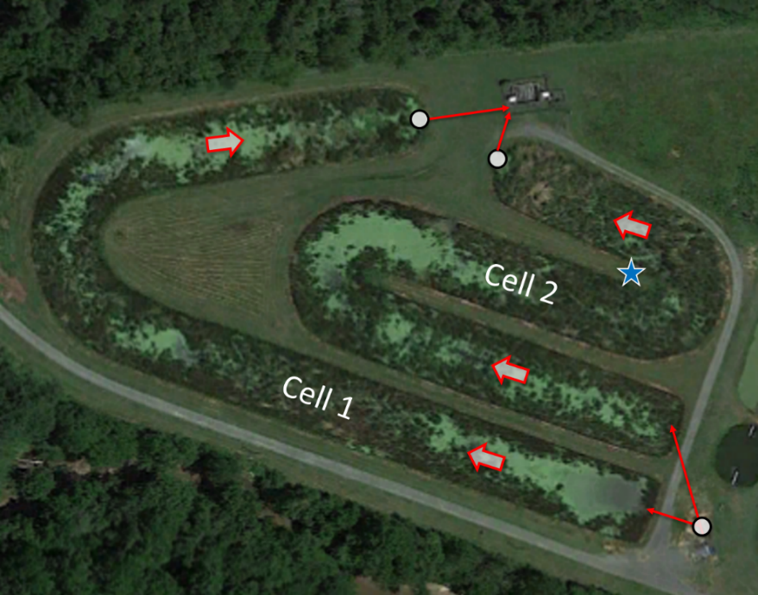

###### Figure 3.1: An aerial view of the constructed wetlands on site. Each cell is the same size. The flow path begins in the bottom right, then moves through the wetlands before exiting to the chlorine contact chamber in the upper central portion of the picture. Sampling locations are shown as white dots. The location of the weather station is shown as a blue star.

At the start of the study in the fall 2018, both wetland cells had been in operation for 22 years and over the previous 12 years NPDES monitoring data had shown a concerning trend of increasing effluent ammonium (NH4-N) concentrations. Over the years, a substantial amount of detritus had accumulated in each cell causing visible short-circuiting, impoundment, and vegetation loss. It was hypothesized that the accumulated detritus in the wetland cells was negatively impacting wetland hydraulic performance and providing an internal source of NH4-N; thereby, severely impacting the nitrogen removal ability of the wetlands. To remediate this issue, a wetland rejuvenation project was initiated with detritus removal and vegetation reestablishment in wetland cell 1 scheduled for late April 2019. Prior to detritus removal cell 1 was drained, exposing the accumulated detritus observed to be approximately 0.4 m thick (Figure 3.2). Excursions into cell 2 suggested that the magnitude of detritus accumulation in that cell was analogous to the observed accumulation in cell 1. Detritus removal was completed using an 18-m long boom excavator to scrap the detritus from the cell bottom and place it on the cell slope. During detritus removal, clumps of detritus containing living cattails were placed back into the cell on rough 1.5-m centers to allow for vegetation reestablishment (Figure 3.3). The first and last 5 m of each cell were not vegetated to provide allow for distribution of the wastewater across the cell width. The cell was brought back online at half capacity, a water column depth of 0.13-m, and vegetation had fully established by July 2019 (Figure 3.4).

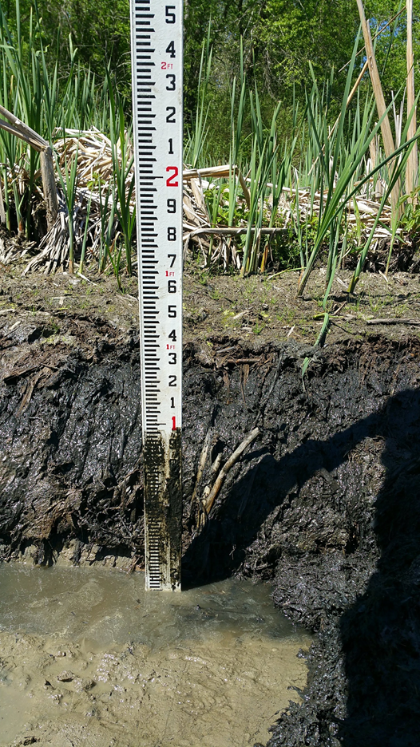 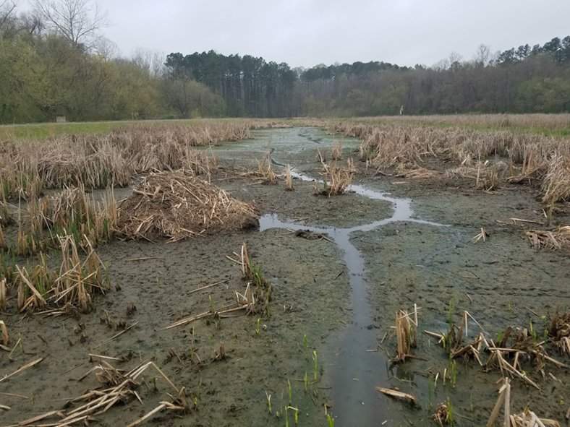

###### Figure 3.2: Left: thickness of accumulated detritus in cell 1. Right: View of wetland cell 1 immediately prior to clean out. Unvegetated short-circuit paths were evident.

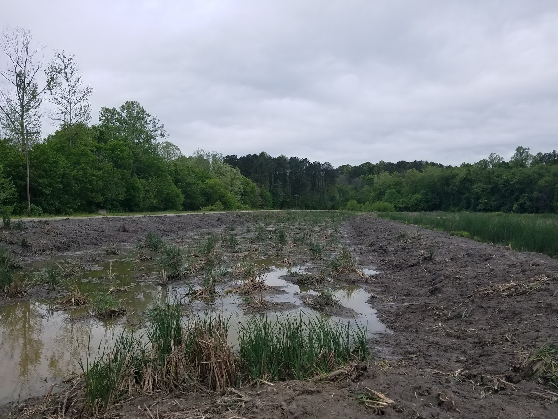

###### Figure 3.3: View of the cell, taken from the cell inlet, displaying the removed detritus now placed on the cell banks and the replanted cattail clumps.

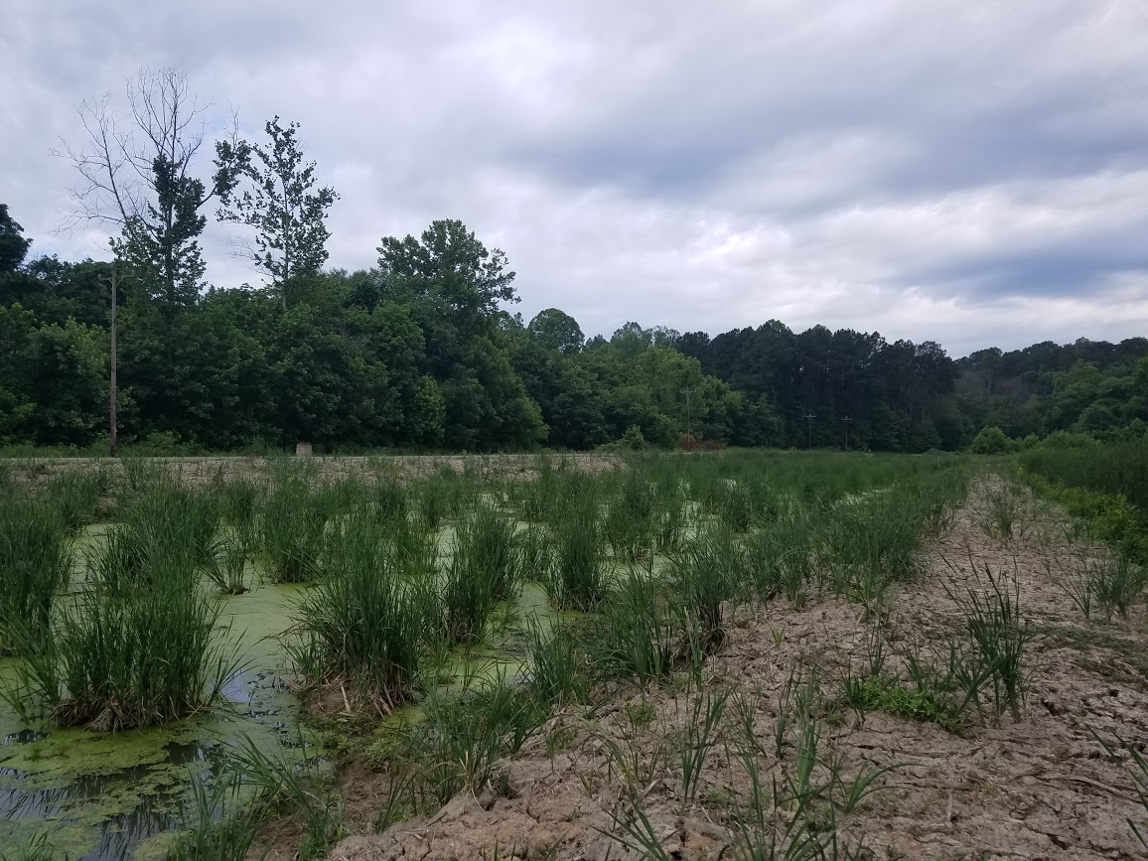 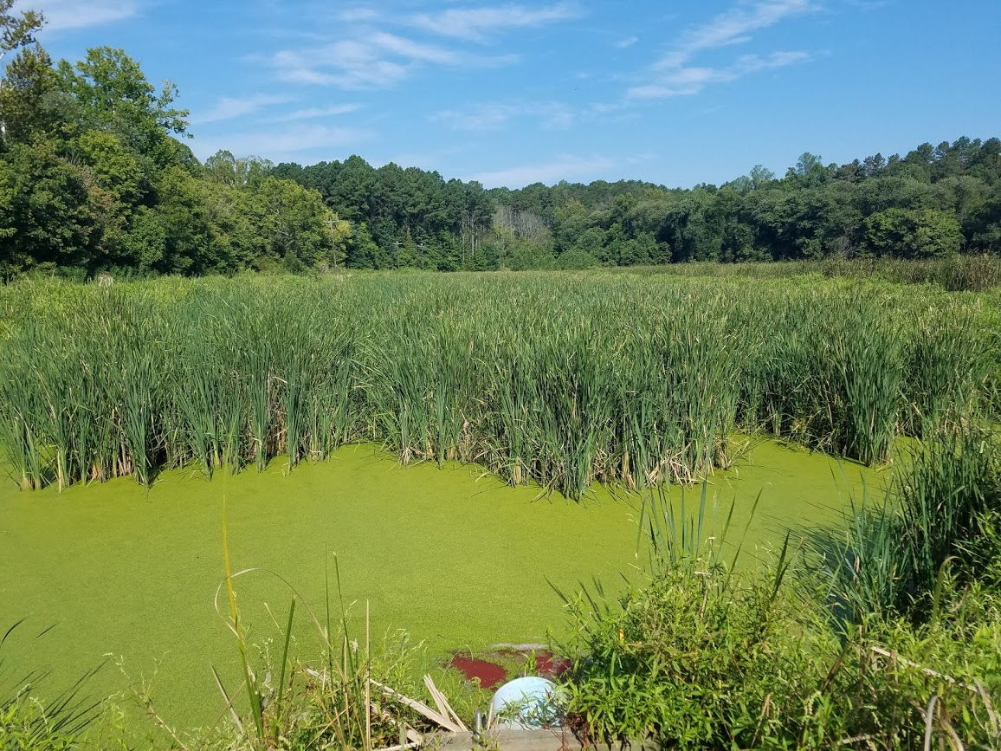

###### Figure 3.4: Left: view of cell 1, taken from just to the right of the cell inlet, soon after the cell was brought back online in mid-May 2019. Right: View of cell 1, taken from the cell inlet, at the start of the July 26th, 2019 tracer tests with vegetation reestablished.

### Data Collection

Tracer tests were conducted when outflows were between 3.15 L/s and 6.31 L/s with nominal retention times ranging from 7.75 to 3.87 days, respectively. The cells were hypothesized to contain substantial hydraulic inefficiencies due to detrital buildup and observed preferential flows that would result in measured retention times significantly lower than the nominal retention times. Rhodamine WT was used as a dye in the study due to availability, low cost, access to a submersible fluorescence sensor, and visual observation capabilities (Figure 3.5). Concern has been raised about the use of Rhodamine WT as a dye to perform hydraulic analysis in wetland systems due to its susceptibility to adsorption on organic material. However, Williams and Nelson (2011) found Rhodamine WT concentrations to be coincident with bromide concentrations in a series of tracer tests conducted on a 1.2-ha treatment wetland. Additionally, Lin et al (2003) suggested that Rhodamine WT is a suitable tracer in wetlands with residence times less than one week. Since each cell is less than 1-ha with maximum nominal retention times of approximately one week, rhodamine WT was deemed acceptable as a tracer dye to analysis the hydraulic properties of the Walnut Cove wetland cells.

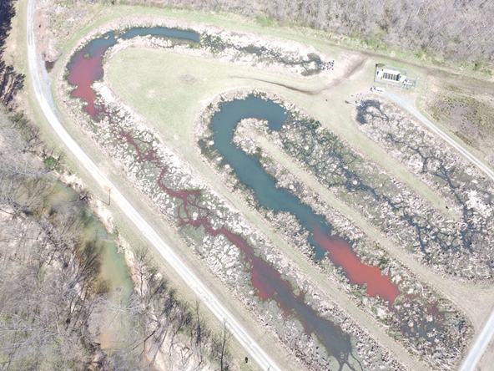

###### Figure 3.5: Areal view of the tracer tests initiated on March 23rd, 2019. This test was conducted prior to wetland cell 1 rejuvenation activities. Limited vegetation coverage is apparent in this photograph. This photo was taken approximately 6 hours after the dye was released. Preferential flow paths are visible in cell 1. The preferential flow paths for cell 2 did not begin until the last half of the cell.

Nine total tracer injections were conducted, five in wetland cell 1 and four in wetland cell 2. The first pilot test was conducted in cell 1 on March 9, 2019 using 35.7 g of Rhodamine WT in a 1 L solution of deionized water. The tracer solution was injected into the target cell influent at the two-way influent-splitter box. The injection was completed in one half hour. Since the first pilot test, there have been four paired tests at the site (Table 3.1). Each subsequent test has followed these same procedures.

Samples were obtained approximately 1 m upstream of the outlet weir using 6712 Portable Teledyne ISCO automated samplers with integrated 730 Bubbler Flow Modules (Teledyne ISCO, Lincoln, NE). The automated samplers were arranged with 24 sample bottles. Although, Headly and Kadlec (2007) suggest 30-40 samples per tracer test, sampling was restricted to 24 bottles due to study constraints. Over the 9 experiments, 700mL samples were taken at time intervals ranging from uniformly spaced two-hour intervals to variable intervals between one and four hours depending on the test (Table 3.1). Tests with uniform two-hour sampling intervals had a 48-hour window to capture the dominant features of the Residence Time Distribution (RTD). Since the 48-hour window was less than the nominal retention time, each test was centered on an estimated actual residence time. Errors in this estimate resulted in some tests missing a majority of either the rising or falling limb. To obtain initial background concentrations (Co), outlet grab samples were taken at the start of each experiment. All samples were brought back to the North Carolina State University Department of Biological and Agricultural Engineering Ecological Restoration Lab for analysis.

##### Table 3.1. Overview of tracer experimental setup

|  |  |  |  |  |  |  |
| --- | --- | --- | --- | --- | --- | --- |
| Test | Start Date | Cell | Period | Time Interval | Sampling Start  Cell 1 Cell 2 | |
| 1 | March 8, 2019 | 1 | Pre | Every 2hrs | t0 + 7hrs |  |
| 2 | March 23, 2019 | 1 and 2 | Pre | Every 2hrs | t0 + 6hrs | t0 + 22hrs |
| 3 | July 26, 2019 | 1 and 2 | Post | Every 2hrs | t0 + 30hrs | t0 + 12hrs |
| 4 | August 9, 2019 | 1 and 2 | Post | Every 2 hrs | t0 + 22hrs | t0 + 12hrs |
| 5 | January 31, 2020 | 1 and 2 | Post | Variable | t0 + 12hrs | t0 + 12hrs |

### Data Analysis

Rhodamine WT concentration was measured in each sample using a Cyclops-7 Fluorometer and Databank Handheld Datalogger (Turner Designs, San Jose, CA). Samples were run in accordance with the recommended measurement practices in Appendix B of the Cyclops Submersible Sensors User’s Manual (2019).

Flow out of each wetland passes over a sharp-crested fully contracted rectangular weir. Head was measured at each outlet every 15 minutes using the 730 Modules with measurement sites placed at a distance greater than four times the maximum expected head over the wear in accordance with the standard fully contracted weir requirements in the Bureau of Reclamation’s Water Measurement Manual (2001). Outflow was calculated using the Francis (1883) equation as stated in the Manual.

$Q=3.33(L-0.2H)(H^{3/2})$ (Equation 3)

Where *Q* = volumetric flow (ft3/s), *L* = length of the weir (ft), and *H* = head on the weir (ft). This equation is valid where H/L ≤ 0.33, which was the case for each experimental period. The 15-minute outflow data were converted to SI units. Based on equation 3, a 0.003 m magnitude stage measurement error can produce an 11 to 18% error in flow rate between 268 m3 d-1 and 544 m3 d-1. To reduce the influence of error-inducing noise from the signal, the 15-min measured flows were averaged to daily outflows.

The average daily outflows were assigned to all samples taken during that day. Any missing data during the study periods were filled using linear relationships between available inflows and outflows over the period the test was conducted. For example, if tracer experiments were conducted in March 2019, the linear relationship would be built with data inflow and outflow data from the pre-cleanout period of 11/01/2018 to 3/29/2019. To alleviate concerns of premature truncation due to limited sampling times, the tails of all tests were extended past the last sample to approximately 2tn using an exponential decay curve fit to the recession limb (Appendix A). The time-weighted average outflows from each cell ranged from 354 to 471 m3d-1, which was just below the average cell outflow during the study period (~490m3d-1) (Table 3.2). The nominal retention time (tnom) for each tracer experiment was calculated using equation 1, which assumes ideal plug flow conditions. Where, V is the volume of the wetland, based on the design basin volume with a water depth based on the outlet weir crest height, and Qavg is the time-weighted average flow during the tracer experiment. Wetland cell conditions for each tracer experiment are shown in Table 3.2.

##### Table 3.2: Details of conditions during tracer tests.

|  |  |  |  |  |  |  |  |
| --- | --- | --- | --- | --- | --- | --- | --- |
| **Date** | **Period** | **Cell** | **Test** | **Water column depth, m** | **Nominal basin volume, m3** | **Avg outflow, m3d-1 (gpm)** | **Nominal residence time, days** |
| 3/8/2019 | pre | 1 | 1 | 0.25 (10”) | 1750 | 463 (84.9) | 3.77 |
| 3/23/2019 | pre | 1 | 2 | 0.25 (10”) | 1750 | 354 (65.0) | 4.94 |
| 7/26/2019 | post | 1 | 3 | 0.13 (5”) | 860 | 471 (86.4) | 1.83 |
| 8/9/2019 | post | 1 | 4 | 0.13 (5”) | 860 | 387 (71.0) | 2.22 |
| 1/31/2020 | post | 1 | 5 | 0.25 (10”) | 1750 | 362 (66.5) | 4.81 |
| 3/23/2019 | pre | 2 | 1 | 0.25 (10”) | 1750 | 364 (66.9) | 4.85 |
| 7/26/2019 | post | 2 | 2 | 0.25 (10”) | 1750 | 444 (81.4) | 3.94 |
| 8/9/2019 | post | 2 | 3 | 0.25 (10”) | 1750 | 361 (66.2) | 4.85 |
| 1/31/2020 | post | 2 | 4 | 0.25 (10”) | 1750 | 377 (69.3 | 4.64 |

#### Residence Time Distribution Analysis

Tracer experiment data were represented using RTDs to evaluate the hydraulic performance of each cell (Bodin et al., 2012, 2013; Kadlec & Wallace, 2009; Levenspiel, 1999; Martinez & Wise, 2003; Wahl et al., 2010). There are two common methods to convert tracer experiment data to an RTD. The first method was the method of moments, which uses numerical integration of measured data. The second method was fitting the observed data to a gamma distribution function by minimizing the sum of squared errors. Both methods were used in the analysis of Walnut Cove tracer experiment data. The theoretical RTD is expressed as a function of time, $E\left(t\right)$, shown in equation 4 (Martinez & Wise, 2003). For direct comparison of the RTDs under different experimental conditions, $E\left(t\right)$ can be normalized by multiplying by the nominal residence time (tnom).

(Equation 4)

Where,

E(t) = residence time distribution (d-1)

Q(t) = volumetric flow exiting the wetland cell (L/d)

C(t) = concentration of tracer exiting the wetland cell (mg/L)

For the method of moments, the RTD for each tracer experiment was estimated using the trapezoid integration rule (equation 5) The zeroth, first, and second moments for the RTD, which correspond to the mass of tracer recovered (Mrec), observed mean residence time (τ) and the spread of the RTD curve (σ2), respectively, can also be estimated using this method (equations 6, 7, and 8).

$E\left(t\right)= \frac{Q\left(t\right)C(t)}{\int_{0}^{∞}{Q\left(t\right)C\left(t\right)dt}}= \frac{Q\left(t\right)C(t)}{M_{0}} ≈\frac{Q\left(t\right)C(t)}{\sum_{i=2}^{n}{\left(\frac{\left(Q\left(t_{i}\right)C\left(t_{i}\right)+Q\left(t_{i-1}\right)C\left(t_{i-1}\right)\right)}{2}\right)}(t_{i}-t_{i-1})}$ (Equation 5)

$M_{rec}=M_{0}= \int_{0}^{∞}{Q\left(t\right)C\left(t\right)dt}≈ \sum_{i=2}^{n}{\left(\frac{\left(Q\left(t_{i}\right)C\left(t_{i}\right)+Q\left(t_{i-1}\right)C\left(t_{i-1}\right)\right)}{2}\right)}(t_{i}-t_{i-1})$ (Equation 6)

$τ=M_{1}= \int_{0}^{∞}{tE\left(t\right)dt} ≈\frac{\sum_{i=2}^{n}{\left(\frac{\left(t_{i}Q\left(t_{i}\right)C\left(t_{i}\right)+t_{i-1}Q\left(t_{i-1}\right)C\left(t_{i-1}\right)\right)}{2}\right)}(t_{i}-t_{i-1})}{\sum_{i=2}^{n}{\left(\frac{\left(Q\left(t_{i}\right)C\left(t_{i}\right)+Q\left(t_{i-1}\right)C\left(t_{i-1}\right)\right)}{2}\right)}(t_{i}-t_{i-1})}$

(Equation 7)

$σ^{2}=M_{2}= \int_{0}^{∞}{t^{2}E\left(t\right)dt- τ^{2}} ≈\left[\frac{\sum_{i=2}^{n}{\left(\frac{\left(t_{i}^{2}Q\left(t_{i}\right)C\left(t_{i}\right)+t_{i-1}^{2}Q\left(t_{i-1}\right)C\left(t_{i-1}\right)\right)}{2}\right)\left(t_{i}-t_{i-1}\right)}}{\sum_{i=2}^{n}{\left(\frac{\left(Q\left(t_{i}\right)C\left(t_{i}\right)+Q\left(t_{i-1}\right)C\left(t_{i-1}\right)\right)}{2}\right)}(t_{i}-t_{i-1})}\right]-τ^{2}$ (Equation 8)

All tracer experiments were evaluated regardless of the percent of mass recovered. Each RTD built using the method of moments was checked to ensure the unity of the RTD is equal to 1. From the observed mean residence time (τ) and the spread of the curve (σ2), the number of tanks-in-series (TIS) parameter (N), was calculated using equation 2. The dimensionless dispersion parameter to be used as the mixing index (σθ2) was calculated using equation 9.

$σ_{θ}^{2}=\frac{σ^{2}}{τ^{2}}$

(Equation 9)

Tracer test results were also analyzed by building an RTD through the fitting the data to the probability density function of the gamma distribution as a function of the parameters (x,α,β) (Equation 10).

$f\left(x,α,β\right)= \frac{β^{α}}{Г\left(α\right)}x^{α-1}e^{-βx}$

(Equation 10)

Where, *x* is time, α is the N parameter, and β is N/τ. In the data fitting process, initial values τ and N parameters were set to those estimated using the method of moments. Optimization was completed by minimizing the sum of squared error between the gamma function and the estimated E(t) from the method of moments (Equation 11).

$SSE= \sum_{i=1}^{n}{{\left[E\left(t_{i}\right)-f(t_{i},N,\frac{N}{τ})\right]}^{2}}$

(Equation 11)

#### Hydraulic Parameters and Indices

For each test, the hydraulic efficiency (e), the number of tanks (N), the estimated mean residence time (τ), and variance of the RTD (σ2) were estimated from both the method of moments and the gamma fit method. The hydraulic efficiency index (λe) was calculated from the hydraulic efficiency and the N value (Equation 12).

$λ_{e}=e\left(1-\frac{1}{N}\right)$

(Equation 12)

To evaluate and compare hydraulic indices, the hydraulic efficiency index (λe), the mixing index (dimensionless dispersion, σΦ2), and the short-circuiting index (dimensionless time at which 10% of recovered tracer mass has left the basin, t10/tnom) were estimated for both the moment and gamma fit methods. The indices from both methods were averaged together to provide a single index value for each cell/period/depth combination. Qualitative evaluation of hydraulic performance was based on modified ranges of hydraulic indices given in Liu et al (2020) and Persson et al (1999) (Table 3.3). All analyses were conducted using R software (R Core Team, 2017). The R script used to perform analysis is in Appendix A.

##### Table 3.3. Ranges of performance for the three evaluated hydraulic indexes. Ranges modified from thresholds presented in Liu et al (2020) and Persson et al (1999).

|  |  |  |  |
| --- | --- | --- | --- |
| Hydraulic Index | Performance Ranges | | |
| **compromised** | **acceptable** | **excellent** |
| λe | ≤ 0.5 | 0.5 – 0.75 | > 0.75 |
| σΦ2 | > 0.2 | 0.1 – 0.2 | 0.0 – 0.1 |
| t10/tnom | 0 – 0.3 | 0.3 – 0.7 | > 0.7 |

## Results

The tracer experiments in Figures 3.6 & 3.7 were conducted prior to wetland rejuvenation in cell 1, while Figures 3.8, 3.9, & 3.10 were conducted after wetland rejuvenation activities. After wetland rejuvenation, cell 1 was held at approximately half its design volume for tests 3 and 4 (Figures 3.8 and 3.9). On August 23rd, 2019, wetland cell 1 was brought back to full volume (0.25-m ponded depth); therefore, the first comparison of the two cells at equal design volume after rejuvenation activities is shown in Figure 3.10. For each tracer experiment, both methods of analysis (moment and gamma fit) were used to create RTDs (Figures 3.5 - 3.10). Cell 1 Test 3, conducted on July 26th, 2019, was the only tracer experiment where the rising limb of the RTD was not captured in the sampling scheme (Figure 3.8). While results from this test are presented in the chapter, it was not used to evaluate wetland hydraulic performance.

The tracer performance metric of tracer mass recovered ranged from 38 to 108% of the initial tracer mass added (Table 3.4). Prior to wetland rejuvenation, cell 1 and cell 2 mean residence times ranged from 0.66 to 1.31 days, hydraulic efficiencies ranged from 0.13 to 0.28 and N values ranged from 2.04 to 4.38. In the period after wetland rejuvenation, cell 2 had an average mean residence time of 1.4 days, average hydraulic efficiency of 0.31, and average N value of 4.62. In comparison, cell 1 average mean residence time increased to 2.32 days, average hydraulic efficiency to 0.68, and an average N value of 9.27.

###### Figure 3.6: Results and analysis of the experiment initiated on March 8th, 2019. This experiment was a pilot test for site and only cell 1 was investigated. Vertical lines represent mean actual residence time (τ) and nominal residence time based on plug-flow characteristics (tnom). The blue line represents the RTD built from the method of moments. The red line represents the RTD built from fitting a gamma distribution.

###### Figure 3.7: Results and analysis of the experiment initiated on March 23rd, 2019. Vertical lines represent mean actual residence time (τ) and nominal residence time based on plug-flow characteristics (tnom). The blue line represents the RTD built from the method of moments. The red line represents the RTD built from fitting a gamma distribution.

###### Figure 3.8: Results and analysis of the experiment initiated on July 26th, 2019. The first experiment conducted after cell 1 detritus removal. Vertical lines represent mean actual residence time (τ) and nominal residence time based on plug-flow characteristics (tnom). The blue line represents RTD built from the method of moments. The red line represents RTD built from fitting a gamma distribution.

###### Figure 3.9: Results and analysis of the experiment initiated on August 9th, 2019. Vertical lines represent mean actual residence time (τ) and nominal residence time based on plug-flow characteristics (tnom). The blue line represents RTD built from the method of moments. The red line represents RTD built from fitting a gamma distribution.

###### Figure 3.10: Results and analysis of the experiment initiated on January 31st, 2019. The first experiment run with cell 1 back to full capacity (basin depth of 10”). Vertical lines represent mean actual residence time (τ) and nominal residence time based on plug-flow characteristics (tnom). The blue line represents RTD built from the method of moments. The red line represents RTD built from fitting a gamma distribution.

##### Table 3.4: Results from tracer test RTD analysis.

|  |  |  |  |  |  |  |  |  |  |  |  |  |  |  |  |
| --- | --- | --- | --- | --- | --- | --- | --- | --- | --- | --- | --- | --- | --- | --- | --- |
| Date | Cell | Mass recovered | Method of Moments | | | | | | Gamma fit method | | | | | | |
| Hydraulic efficiency | # of tanks | Mean  residence time | Hydraulic efficiency Index | Time to 10% | Dimensionless variance | Hydraulic efficiency | # of tanks | Mean residence time | Hydraulic efficiency Index | Time to 10% | Dimensionless variance |
|  |  | % | ev | N | τ (days) | λe | t10 | σΦ2 | ev | N | τ (days) | λe | t10 | σΦ2 |
| 3/8/2019 | 1 | 63.67 | 0.28 | 2.87 | 1.06 | 0.18 | 0.12 | 0.35 | 0.24 | 4.09 | 0.91 | 0.18 | 0.12 | 0.24 |
| 3/23/2019 | 1 | 64.15 | 0.16 | 2.04 | 0.81 | 0.08 | 0.06 | 0.49 | 0.13 | 3.36 | 0.66 | 0.09 | 0.06 | 0.3 |
| 7/26/2019 | 1 | 64.01 | 0.86 | 6.48 | 1.57 | 0.73 | 0.13 | 0.15 | 0.63 | 6.45 | 1.15 | 0.53 | 0.13 | 0.16 |
| 8/9/2019 | 1 | 103.24 | 0.81 | 3.44 | 1.79 | 0.57 | 0.29 | 0.29 | 0.66 | 4.6 | 1.47 | 0.52 | 0.29 | 0.22 |
| 1/31/2020 | 1 | 108.95 | 0.63 | 13.68 | 3.05 | 0.58 | 0.44 | 0.07 | 0.62 | 15.37 | 2.97 | 0.58 | 0.44 | 0.07 |
| 3/23/2019 | 2 | 51.51 | 0.27 | 4.28 | 1.31 | 0.21 | 0.05 | 0.23 | 0.21 | 4.38 | 0.99 | 0.16 | 0.05 | 0.23 |
| 7/26/2019 | 2 | 38.18 | 0.33 | 2.48 | 1.31 | 0.20 | 0.12 | 0.40 | 0.29 | 3.19 | 1.15 | 0.20 | 0.12 | 0.31 |
| 8/9/2019 | 2 | 38.18 | 0.43 | 3.34 | 2.11 | 0.30 | 0.21 | 0.30 | 0.37 | 4.84 | 1.8 | 0.29 | 0.21 | 0.21 |
| 1/31/2020 | 2 | 97.84 | 0.25 | 3.01 | 1.17 | 0.17 | 0.14 | 0.33 | 0.19 | 10.87 | 0.86 | 0.17 | 0.14 | 0.09 |

During the period prior to wetland rejuvenation, both wetland cells had a hydraulic efficiency index (λe) less than 0.2, a short-circuiting index (t10/tnom) less than 0.1, and a mixing index (σΦ2) greater than 0.2 (Table 3.5). Comparing these values to the ranges of hydraulic performance in Table 3.3, both wetland cells were compromised with poor hydraulic performance. During the period after wetland rejuvenation, cell 2 had an average λe value near 0.2, average t10/tnom value less than 0.2, and an average σΦ2 value greater than 0.2 (Table 3.5). Based on Table 3.3, cell 2 was still compromised with poor hydraulic performance. Meanwhile, cell 1, when held at a normal pool depth of 0.13-m, had a λe value of 0.55, t10/tnom value of 0.29, and σΦ2 value of 0.26. The hydraulic efficiency index had raised to acceptable, but the short-circuiting and mixing indexes (t10/tnom and σΦ2) were still compromised. When the cell 1 water column depth was raised back to the typical 0.25-m, cell 1 had a λe value of 0.58, t10/tnom value of 0.44 and σΦ2 value of 0.07. Based on this tracer test, cell 1 had an acceptable performance for hydraulic efficiency and short-circuiting, with an excellent performance for mixing.

##### Table 3.5: Average hydraulic indices for both cells over the study period. The three dimensionless parameters (λe, t10, σΦ2), were averaged over both the moment and gamma fit analysis. Tracer test 3 for cell 1 was omitted from this analysis since no samples were obtained in the rising limb of the RTD. Three cell/period/depth combinations only had one test from which to average the hydraulic indices derived from both RTD formation methods.

|  |  |  |  |  |  |  |  |
| --- | --- | --- | --- | --- | --- | --- | --- |
| Cell | Period | Tests | Flow, m3d-1 | Ponded Depth, m | λe | t10/tnom | σΦ2 |
| 1 | Pre | 2 | 409 | 0.25 (10”) | 0.13 | 0.09 | 0.35 |
| 2 | Pre | 1 | 365 | 0.25 (10”) | 0.19 | 0.05 | 0.23 |
| 1 | Post | 1 | 387 | 0.13 (5”) | 0.55 | 0.29 | 0.26 |
| 1 | Post | 1 | 363 | 0.25 (10”) | 0.58 | 0.44 | 0.07 |
| 2 | Post | 3 | 394 | 0.25 (10”) | 0.22 | 0.16 | 0.27 |

## Discussion

### What was the effectiveness of wetland rejuvenation on hydraulic performance?

Figures 3.6, 3.7 and Tables 3.4 and 3.5 show that both wetland cells were hydraulically compromised with poor performance in the period prior to wetland rejuvenation. The poor performance observed by these tracer tests confirmed the hypothesis that both cells at the site were hydraulically compromised prior to wetland rejuvenation activities. Upon detritus removal and vegetation reestablishment, the cell was partially refilled on May 11th, 2019 to a water column depth of 0.13-m. While the cell was still set at this lower depth, cell 1 test 4, conducted on August 9th, 2019, showed that hydraulic efficiency of the cell had improved to 0.81 with the hydraulic efficiency index increasing to 0.55. A hydraulic efficiency index of 0.55 indicates that the cell has an acceptable or satisfactory hydraulic performance (Table 3.3). While hydraulic efficiency increased, short-circuiting and mixing indices were still compromised (Table 3.5). The hydraulic efficiency index is the hydraulic index of greatest importance due to the comprehensive insight into wetland hydrodynamics it provides; however, the lack of improvement the other two indices was concerning. It has been hypothesized that continued poor performance in short-circuiting was likely due to the microtopography of the cell derived from replanting cattail clumps (Figures 3.2 and 3.3). At low water column depths, the microtopography of the cell allowed for the formation of channels parallel to flow through the cell likely resulting in preferential flow paths. The lack of improvement in mixing was also hypothesized to be caused by the shallow water column depths, which can be more easily mixed by physical processes and weather conditions.

On August 23rd, 2019, the cell 1 outlet weir was finally switched to match the cell 2 outlet weir. After this date, both wetland cells had identical inlet and outlet weir stages, therefore the pair of tracer tests conducted on January 31st, 2019 (cell 1 test 5 and cell 2 test 4) were the first to directly compare the cells with the same hydrologic conditions and design volumes. Cell 1 test 5 produced an acceptable hydraulic efficiency index (0.58), an acceptable short-circuiting index (0.44), and an excellent mixing index (0.07) (Figure 3.10, Table 3.5). The improved short-circuiting was likely caused by the greater water depth, which allowed water to flow over the microtopography caused by the cattail clumps. It is hypothesized that the improved mixing index value, lower mixing in the cell, was also a product of the increased water column depth combined with the colder temperature limiting biological activities and the fallen vegetation providing surface cover, which would limit mixing by shielding the wetland water column from weather conditions. During the post-rejuvenation period, three tracer tests were run in cell 2 (tests 2, 3, and 4). The average hydraulic efficiency index (0.22), short-circuiting index (0.16), mixing index (0.27) were all considered compromised based on Table 3.3 and indicative of poor performance. The observation of improved hydraulic performance in the rejuvenated cell 1, compared to the maintained poor performance in non-rejuvenated cell 2 provided strong evidence that wetland rejuvenation, in the form of detritus removal and vegetation reestablishment was capable of substantially improving the hydraulic performance of constructed wetlands negatively impacted by the aging process.

### What are limitations of the approach used?

Study limitations were derived from equipment, personnel, and travel constraints that reduced sampling effectiveness. Headley and Kadlec (2007) suggest taking 30-40 flow-weighted samples over will be the most accurate sampling of the tracer response curve. However, each automatic sampler had only 24 sample bottles available for each tracer test and once a week site visits limited bottle refill. To maneuver around this constraint, an estimated mean residence time was used to center the sampling window. While, these estimates were fairly accurate, the rising limb of the Cell 1 test 3 RTD, conducted on July 26, 2019, was not captured in the samples due to an overestimation of mean residence time and subsequent lag in initiating the sampling program (Figure 3.8). Additionally, a lack of available samples leads to the early truncation of RTDs, which was remedied by extrapolating the tail as an exponential decay function. While these constraints did not invalidate the tracer tests, after constraints were lifted in May 2020 and each subsequent tracer test followed sampling rules of thumb provided by Headley and Kadlec (2007).

The tracer mass recovered were lower than expected for several tests, especially in cell 2. Low mass recovery in highly organic wetlands due to adsorption to organic material has been noted as reason against using Rhodamine WT dye for wetland tracer tests (Kadlec & Wallace, 2009; Lin et al., 2003; Williams & Nelson, 2011). While the lack of mass balance closure allows for questions about the representativeness of the RTDs formed from these tracer tests, site visits in the immediate aftermath of tests (5 to 7 days after tests were initiated) were unable to observe Rhodamine WT dye within the cells so it does not seem that a second peak in the data was missed. The author is confident that the shape of the RTD, which is used to determine hydraulic performance, gathered from the tracer tests accurately represented the hydraulics of the system, even without closure of the tracer mass balance.

### What is the use of these results in an applied or research setting?

The N values are necessary to build TIS models for wetland treatment performance (Kadlec & Wallace, 2009; Wang et al., 2006). The use of tracer tests to obtain estimates of N values in aging wetlands may provide a method for estimating the magnitude of internal nitrogen sources (i.e. the background concentration parameter) in a wetland through the fitting of a TIS model. Additionally, if the dimensionless variance, σΦ2, parameter derived from the RTD is assumed to be constant over a period, the mean residence time at any flow rate during that same period can be estimated using equation 13 (Wang et al., 2006).

$τ=\frac{Q_{r}}{Q}τ_{r}$

(Equation 13)

Where, the mean residence time τ, can be estimated from a flow rate, Q, and the mean residence time, τr, and flow rate, Q, derived from a reference tracer test during the same period.

These results show that a relatively simple wetland rejuvenation can provide immediate improvement to wetland hydraulic performance. There is a strong positive relationship between wetland pollutant removal and wetland hydraulic performance. Wetland rejuvenation techniques focused on hydraulic performance improvement should be considered a primary method by which aging wetlands with reduced treatment performance can be improved and their design life extended. While the work shown in this chapter is highly encouraging, it is limited by the short-term nature of the study, with hydraulic performance being evaluated between three months and two years after rejuvenation. Over time, the newly reestablished vegetation will begin to refill the cell with detritus and compromise hydraulic performance. Future work should continue to investigate the hydraulic performance of the wetlands with a focus on changes in hydraulic performance over time. Long-term hydraulic performance study could provide more robust estimates for the timing of rejuvenation activities and the duration of improved hydraulic performance.

### How could you improve rejuvenation techniques?

The detritus removed from the cell was placed on the cell side slopes to direct leaching pollutants back into the cell. The exposure to aerobic conditions expected by placing the detritus on the side slopes will compact and slowly breakdown the accumulated detritus over time. However, by placing the removed detritus on the side slopes, the cell width post-rejuvenation was less than the design cell width. Therefore, comparisons to initial design volumes (i.e hydraulic efficiency and hydraulic efficiency index) were bound to be less than ideal because the rejuvenated cell volume was smaller than the initial design volume. Post-rejuvenation hydraulic efficiency may be improved by placing the removed detritus outside of the cell, though this method runs the risk of leaching pollutants outside the basin.

Another option that could have improved hydraulic efficiency was the creation of deep open areas perpendicular to flow can provide breaks in short-circuiting by allowing the water to be redistributed across the width of the basin. At Walnut Cove, basin bathymetry was designed and constructed to maintain a consistent elevation throughout the cell (i.e the cell had a flat bottom). The lack of variation in bathymetry provided a potential opportunity to implement these deep zones. However, fear of breaching the impermeable layer and impacting groundwater prevented the modification of cell bathymetry. Additionally, data gathered in Kadlec and Wallace (2009) suggests that wetland cells with high aspect ratios, which is true of Walnut Cove, do not profit from deep open areas.

## Conclusion

The study presents the hydraulic performance of two aging wetland (> 20 years old) and the impact of wetland rejuvenation techniques on hydraulic performance. Two aging constructed wetland cells of identical volume and aspect ratio with declining pollutant removal performance were studied. One wetland cell (cell 1) was rejuvenated via detritus removal and vegetation reestablishment, while the other cell (cell 2) was left in its initial condition to serve as a reference. Analysis of hydraulic performance was carried out by performing dye (Rhodamine WT) tracer tests. Initial tracer tests performed prior to rejuvenation suggested that both cells had poor hydraulic performance with values of hydraulic efficiency, short-circuiting, and mixing indices falling in the range of compromised wetland hydraulics. After wetland rejuvenation, the cell 1 values for each performance index all moved to values that fell within either the satisfactory or excellent ranges. Meanwhile, cell 2 values remained in the compromised range for all three indices.

Results demonstrated that wetland rejuvenation can improve hydraulic performance. The positive influence of hydraulic performance on pollutant removal suggests that wetland rejuvenation will also result in improved wetland treatment ability. In terms of extending the life of constructed wetland, the evidence presented is short-term but promising. If the hydraulic performance of the cell is be maintained at the post-rejuvenation levels this study could easily change the classic narrative cycle of constructed wetland start-up, maintained performance, decline, and failure. Alternatively, when decline is observed, it should be viewed as the end of just the first cycle in the wetland’s design life, at which time wetland rejuvenation techniques can be used to bring the wetland into the second cycle of its life.

## References

Bodin, H., Mietto, A., Ehde, P. M., Persson, J., & Weisner, S. E. B. (2012). Tracer behaviour and analysis of hydraulics in experimental free water surface wetlands. *Ecological Engineering*, *49*, 201–211. https://doi.org/10.1016/j.ecoleng.2012.07.009

Bodin, H., Persson, J., Englund, J.-E., & Milberg, P. (2013). Influence of residence time analyses on estimates of wetland hydraulics and pollutant removal. *Journal of Hydrology*, *501*, 1–12. https://doi.org/10.1016/j.jhydrol.2013.07.022

Carleton, J. N. (2002). Damköhler number distributions and constituent removal in treatment wetlands. *Ecological Engineering*, *19*(4), 233–248. https://doi.org/10.1016/S0925-8574(02)00094-0

Francis, J. B. (1883). *Lowell Hydraulics Experiments* (fourth). D. Van Nostrand.

Gersberg, R. M., Elkins, B. V., & Goldman, C. R. (1983). Nitrogen removal in artificial wetlands. *Water Research*, *17*(9), 1009–1014. https://doi.org/10.1016/0043-1354(83)90041-6

Headley, T. R., & Kadlec, R. H. (2007). Conducting hydraulic tracer studies of constructed wetlands: A practical guide. *Ecohydrology & Hydrobiology*, *7*(3), 269–282. https://doi.org/10.1016/S1642-3593(07)70110-6

Ingersoll, T. L., & Baker, L. A. (1998). Nitrate removal in wetland microcosms. *Water Research*, *32*(3), 677–684. https://doi.org/10.1016/S0043-1354(97)00254-6

Kadlec, R. H. (2000). The inadequacy of first-order treatment wetland models. *Ecological Engineering*, *15*(1–2), 105–119. https://doi.org/10.1016/S0925-8574(99)00039-7

Kadlec, R. H., & Wallace, S. D. (2009). *Treatment Wetlands* (2nd ed.). CRC Press.

Levenspiel, O. (1999). *Chemical Reaction Engineering* (3rd ed.). Wiley.

Lin, A. Y.-C., Debroux, J.-F., Cunningham, J. A., & Reinhard, M. (2003). Comparison of rhodamine WT and bromide in the determination of hydraulic characteristics of constructed wetlands. *Ecological Engineering*, *20*(1), 75–88. https://doi.org/10.1016/S0925-8574(03)00005-3

Liu, J., Dong, B., Zhou, W., & Qian, Z. (2020). Optimal selection of hydraulic indexes with classical test theory to compare hydraulic performance of constructed wetlands. *Ecological Engineering*, *143*, 105687. https://doi.org/10.1016/j.ecoleng.2019.105687

Martinez, C. J., & Wise, W. R. (2003). Hydraulic Analysis of Orlando Easterly Wetland. *Journal of Environmental Engineering*, *129*(6), 553–560. https://doi.org/10.1061/(ASCE)0733-9372(2003)129:6(553)

Persson, J., Somes, N. L. G., & Wong, T. H. F. (1999). Hydraulics Efficiency of Constructed Wetlands and Ponds. *Water Science and Technology; London*, *40*(3), 291–300.

R Core Team. (2017). *R: A language and environment for statistical computing.* R Foundation for Statistical Computing. https://www.R-project.org/

Thackston, E. L., Shields, F. D., & Schroeder, P. R. (1987). Residence Time Distributions of Shallow Basins. *Journal of Environmental Engineering*, *113*(6), 1319–1332. https://doi.org/10.1061/(ASCE)0733-9372(1987)113:6(1319)

Toet, S., Logtestijn, R. S. P., Kampf, R., Schreijer, M., & Verhoeven, J. T. A. (2005). The effect of hydraulic retention time on the removal of pollutants from sewage treatment plant effluent in a surface-flow wetland system. *Wetlands*, *25*(2), 375–391. https://doi.org/10.1672/13

Turner Designs. (2019). *Cyclops Submersible Sensors User’s Manual*. Turner Designs. http://docs.turnerdesigns.com/t2/doc/manuals/998-2100.pdf

US Department of the Interior. (2001). *Water Measurement Manual* (3rd ed.). US Department of the Interior, Bureau of Reclamation.

Wahl, M. D., Brown, L. C., Soboyejo, A. O., Martin, J., & Dong, B. (2010). Quantifying the hydraulic performance of treatment wetlands using the moment index. *Ecological Engineering*, *36*(12), 1691–1699. https://doi.org/10.1016/j.ecoleng.2010.07.014

Wang, H., Jawitz, J. W., White, J. R., Martinez, C. J., & Sees, M. D. (2006). Rejuvenating the largest municipal treatment wetland in Florida. *Ecological Engineering*, *26*(2), 132–146. https://doi.org/10.1016/j.ecoleng.2005.07.016

Williams, C. F., & Nelson, S. D. (2011). Comparison of Rhodamine-WT and bromide as a tracer for elucidating internal wetland flow dynamics. *Ecological Engineering*, *37*(10), 1492–1498. https://doi.org/10.1016/j.ecoleng.2011.05.003

## Appendix A: Exponential decay functions and R Code

#### Exponential decay plots for each test

###### 

###### Figure A.1: The exponential decay function used to extend cell 1 test 1 data past the sampling truncation point. The exponential decay formula and R2 value are in the top right of the figure.

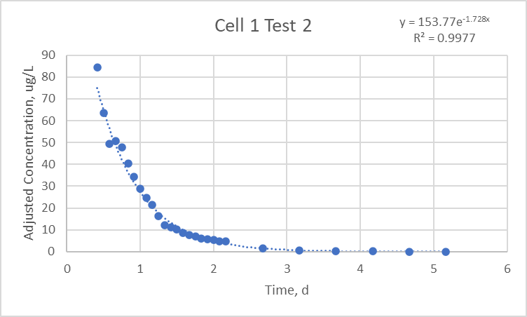

###### Figure A.2: The exponential decay function used to extend cell 1 test 2 data past the sampling truncation point. The exponential decay formula and R2 value are in the top right of the figure.

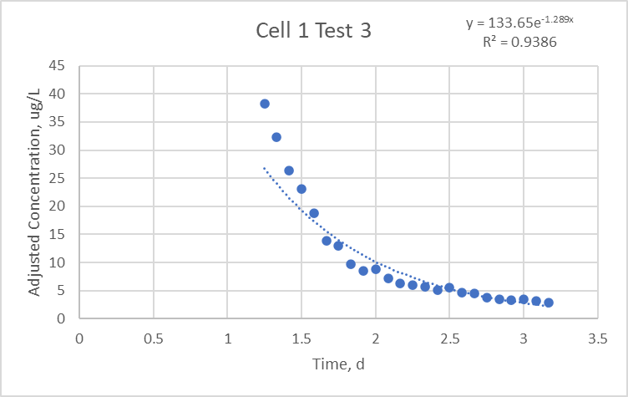

###### Figure A.3: The exponential decay function used to extend cell 1 test 3 data past the sampling truncation point. The exponential decay formula and R2 value are in the top right of the figure.

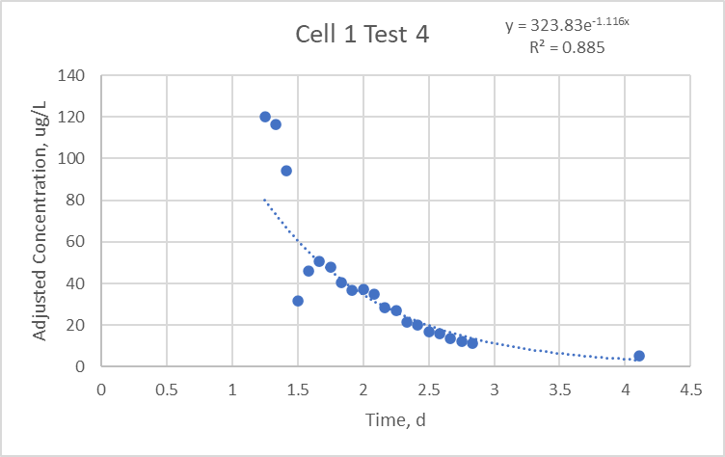

###### Figure A.4: The exponential decay function used to extend cell 1 test 4 data past the sampling truncation point. The exponential decay formula and R2 value are in the top right of the figure.

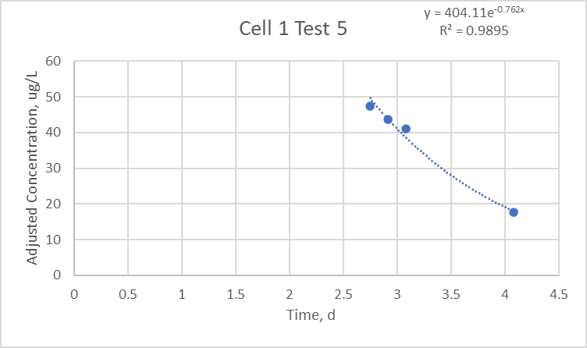

###### Figure A.5: The exponential decay function used to extend cell 1 test 5 data past the sampling truncation point. The exponential decay formula and R2 value are in the top right of the figure.

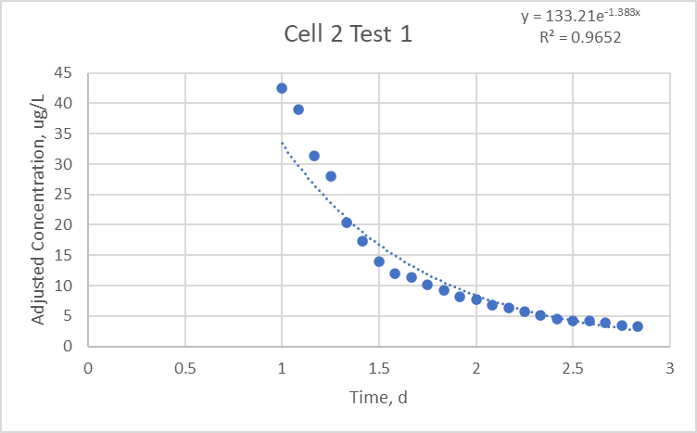

###### Figure A.6: The exponential decay function used to extend cell 2 test 1 data past the sampling truncation point. The exponential decay formula and R2 value are in the top right of the figure.

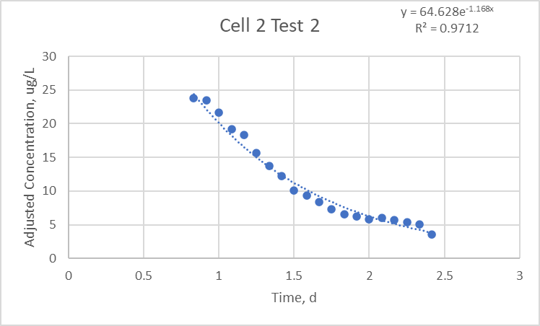

###### Figure A.7: The exponential decay function used to extend cell 2 test 2 data past the sampling truncation point. The exponential decay formula and R2 value are in the top right of the figure.

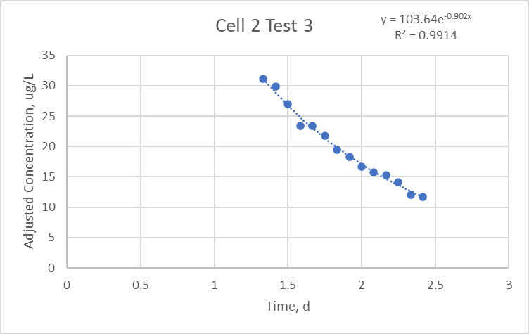

###### Figure A.8: The exponential decay function used to extend cell 2 test 3 data past the sampling truncation point. The exponential decay formula and R2 value are in the top right of the figure.

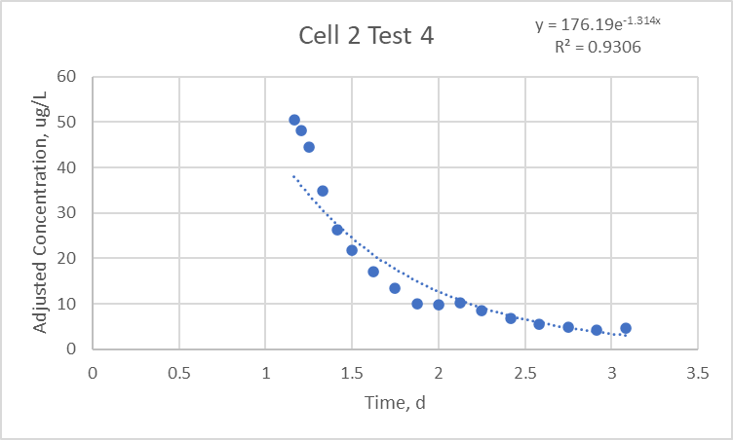

###### Figure A.9: The exponential decay function used to extend cell 2 test 4 data past the sampling truncation point. The exponential decay formula and R2 value are in the top right of the figure.

#### R code example for hydraulic analysis

#Author: Brock Kamrath

#Date Created: 3/26/2020

#Objective: Hydraulic analysis of common dataset format for tracer tests at walnut Cove

#load packages

rm(list=ls(all=TRUE))

library(tidyverse)

library(lubridate)

library(plyr)

library(dplyr)

library(readxl)

library(formattable)

# C value needed for plotting RTDs

c <- 1

# list of file names in the hydrualic_analysis folder and with the tt_o2 start of name

filenames <- list.files(path = "hydraulic_analysis/",

pattern = "tt_o2",

full.names = TRUE)

# limits list to the first four filenames, which is equal to the four test files

filenames <- filenames[1:4]

for (f in filenames) {

data <- read_excel(f, sheet = "main_ext")

#site sheet has the weir plate and tracer volume

site <- read_excel(f, sheet = "site")

head(data)

# Wetland Description

# plate # at outlet weir

weir_num <- site$weir[1]

# Volume of tracer used (L)

trace_vol <- site$trace_vol[1]

if(weir_num == 4){

#nominal wetland volume (L)

V <- 1751605

} else {

#nominal wetland volume (L)

V <- 859604

}

#Mass of tracer added (ug)

mass_added <- 238000000*trace_vol

#find the time weighted average flow during the tracer test

# Time weighted average flow (Lpd)

Q_avg <- sum(data$Q_Lpd*data$deltat_d)/sum(data$deltat_d)

# Time weighted average flow (gpm)

Q_avg_gpm <- Q_avg/(3.785*24*60)

#Nominal retention time (days)

t_nom <- V/Q_avg

#Calculate the theta value

data <- data%>%

mutate(time_prev = lag(time_d),

Q_Lpd_prev = lag(Q_Lpd),

C_ugL_prev = lag(C_ugL))

#set a vector for M0 to NA values

data$M0 <- as.numeric(rep(NA,nrow(data)))

#set a vector for e(t) to NA values

data$e_t <- as.numeric(rep(NA,nrow(data)))

#set a vector for e(t) to NA values

data$e_t_deltat_d <- as.numeric(rep(NA,nrow(data)))

#set a vector for f(t) to NA values

data$f_t <- as.numeric(rep(NA,nrow(data)))

#set a vector for M1 to NA values

data$M1 <- as.numeric(rep(NA,nrow(data)))

#set a vector for M2 to NA values

data$M2 <- as.numeric(rep(NA,nrow(data)))

# set the first M0 value to 0

data$M0[1] <- 0

# set the first M1 value to 0

data$M1[1] <- 0

# set the first M2 value to 0

data$M2[1] <- 0

# set the first e_t_deltat_d value to 0

data$e_t_deltat_d[1] <- 0

# set the first e_t_deltat_d value to 0

data$f_t[1] <- 0

#for loop to solve for M0

for(i in 2:nrow(data)){

data$M0[i] <- (((data$Q_Lpd[i-1]*data$C_ugL[i-1])+(data$Q_Lpd[i]*data$C_ugL[i]))/2)*(data$time_d[i]-data$time_d[i-1])

}

# sum of mass recovered in ug

M0_sum <- sum(data$M0)

#for loop to solve for e_t

for(i in 1:nrow(data)){

data$e_t[i] <- (data$Q_Lpd[i]*data$C_ugL[i])/M0_sum

}

#for loop to solve for e_tavgdeltat and f_t

for(i in 2:nrow(data)){

data$e_t_deltat_d[i] <- ((data$e_t[i]+data$e_t[i-1])/2)*(data$time_d[i]-data$time_d[i-1])

data$f_t[i] <- data$e_t_deltat_d[i]+data$f_t[i-1]

}

#check for unity

unity <- sum(data$e_t_deltat_d)

# for loop to solve for M1 and M2

for(i in 2:nrow(data)){

data$M1[i] <- (((data$time_d[i-1]*data$Q_Lpd[i-1]*data$C_ugL[i-1])+(data$time_d[i]*data$Q_Lpd[i]*data$C_ugL[i]))/2)*(data$time_d[i]-data$time_d[i-1])

data$M2[i] <- ((((data$time_d[i-1]^2)*data$Q_Lpd[i-1]*data$C_ugL[i-1])+((data$time_d[i]^2)*data$Q_Lpd[i]*data$C_ugL[i]))/2)*(data$time_d[i]-data$time_d[i-1])

}

#mass recovered (%)

mass_rec <- (M0_sum/mass_added)*100

# 10% of mass recoverd through the system

m10 <- 0.1*M0_sum

# Actual retention time, First normalized moment (d)

tau <- sum(data$M1)/M0_sum

# Effective volume as decimal

e <- tau/t_nom

# The normalized second moment of the RTD, varience (d^2)

sigma2 <- (sum(data$M2)/M0_sum)-(tau^2)

#N value for method of moments

N <- (tau^2)/sigma2

# Î»e is similar to Î»m due to the numerically equal value between Î»m and e,

# but is animprovement on Î»m. Î»e reflects the RTD shape due to addition of N in

# the formula

lamda_e <- e*(1-(1/N))

#sigma theta is a dimensionless measure of dispersive processes

sigma_theta2 <- sigma2/(tau^2)

# Calucualte the when 10% of the mass added reaches the outlet relative to t_nom

mass_cum <- cumsum(data$M0)

time_d <- data$time_d

t10 <- 0

for(i in 1:length(mass_cum)){

if(m10 > mass_cum[i]){

t10 <- ((m10-mass_cum[i])/(mass_cum[i+1]-mass_cum[i])*(time_d[i+1]-time_d[i]))+time_d[i]

}

}

#normalize t10

t10n <- t10/t_nom

obs <- data.frame(data$time_d, data$e_t)

colnames(obs)

obs1 <- obs %>%

setNames(c('date','E_t'))

ggplot(data)+

geom_point(aes(x=time_d,y=e_t))+

geom_line(aes(x=time_d,y = f_t),color="blue")+

geom_vline(aes(xintercept=tau))

#Moment analysis using Gamma distribution

gamma <- function(data,N,tau){

dat <- data%>%

mutate(e_t = dgamma(time_d, shape = N, scale=tau/N),

f_t = pgamma(time_d, shape = N, scale=tau/N))

outputs <- data.frame(date=dat$time_d,e_t=dat$e_t,f_t=dat$f_t)

return(outputs)

}

#1.par: Define initial values - N, tau----

#use nominal values provided

initial_values <- c(N,tau)

#2.fn: function that returns the SSE ----

#for model, which will be minimized

error <- function(parameters,observed_repsonses,explanatory_variables){

#Assign initial values to parameters

#N value from data

N <- parameters[1]

#tau

tau <- parameters[2]

#Run model

simulated_responses <- gamma(explanatory_variables,N,tau)

#Merge with observations

sim_obs <- inner_join(observed_repsonses,simulated_responses,by="date")

#Calculate SSE

sse <- sum((sim_obs$E_t-sim_obs$e_t)^2)

#Return

return(sse)

}

#read in weather file

dat <- data

observations <- obs1

# Calibrate

cal <- optim(par=initial_values,

fn=error,

gr=NULL,

observed_repsonses=observations,

explanatory_variables=dat,

method="Nelder-Mead")

cal

#apply calibrated maize model

simulation <- gamma(data,N=N,tau=tau)

simulation_calibrated <- gamma(data,N=cal$par[1],tau=cal$par[2])

###################################################

# check for unity in gamma fit

#set a vector for M0 to NA values

simulation_calibrated$e_t_deltat_d <- as.numeric(rep(NA,nrow(data)))

# set first value to zero

simulation_calibrated$e_t_deltat_d[1] <- 0

#for loop

for(i in 2:nrow(simulation_calibrated)){

simulation_calibrated$e_t_deltat_d[i] <- ((simulation_calibrated$e_t[i]+simulation_calibrated$e_t[i-1])/2)*(simulation_calibrated$date[i]-simulation_calibrated$date[i-1])

}

# Check on values for unity, should be 1

unity_gam <- sum(simulation_calibrated$e_t_deltat_d)

####################################################

e_gamma <- cal$par[2]/t_nom

lamda_e_gamma <- (cal$par[2]/t_nom)*(1-(1/cal$par[1]))

sigma_theta2_gamma <- 1/cal$par[1]

for(i in 1:nrow(simulation_calibrated)){

if(simulation_calibrated$f_t[i] < 0.10){

t10_gam <- (((0.10-simulation_calibrated$f_t[i])/(simulation_calibrated$p_t[i+1]-simulation_calibrated$f_t[i])*(simulation_calibrated$date[i+1]-simulation_calibrated$date[i]))+simulation_calibrated$date[i])

t10_gam <- t10/t_nom

}

}

results <- c(mass_rec,Q_avg,e,N,tau,lamda_e,t10n,sigma_theta2,e_gamma,cal$par[1],cal$par[2],lamda_e_gamma,t10_gam,sigma_theta2_gamma,unity,unity_gam)

results <- formattable(results, digits = 2, format = "f")

print(results)

#########################################################################

Q_m3d <- round(Q_avg/1000) # Convert average Q from Lpd to m3d

tau_avg <- (tau+cal$par[2])/2

mytitle <- substitute(paste("Cell 2 Test #",c,), list(c=c)) # Plot title with c variable for test

mysubtitle <- substitute(paste("Average outflow = ",Q_m3d,~"m"^3~"d"^-1),list(Q_m3d=Q_m3d)) # Subtitle states average outflow for test

colors <- c("Moments" = "blue","Gamma Fit" = "red") # Color values for legend

# Create plots for each tracer test with both methods displayed

p <- ggplot()+

geom_point(data=data,aes(time_d,e_t),color="black")+

geom_line(data=simulation,aes(date,e_t,color="Moments"))+

geom_line(data=simulation_calibrated,aes(date,e_t, color="Gamma Fit"))+

geom_vline(aes(xintercept=tau_avg),color="gray70")+

geom_vline(aes(xintercept=t_nom),linetype = 2, color="gray40")+

geom_label(aes(x=tau_avg,y=1.5),label=expression(paste(tau)),size = 6)+

geom_label(aes(x=t_nom,y=1.25),label= expression(paste("t"["nom"])),size=4)+

labs(x="Days",y=expression(paste("Days"^-1)),color = "Legend", title = mytitle, subtitle = mysubtitle)+

lims(x=c(0,7), y=c(0,1.7))+

scale_color_manual(values = colors)+

theme_classic()

# Print plots

print(p)

# Add 1 to the C variable that states the test number for the plot title

c <- c+1

}